Section 11: Dates & Times
I. Dates & times in JavaScript
Const now = new Date( )
When we create a new date, it automatically assigns it the date of now, this moment in time when we run the file.
The “new”, which is this it looks a bit like a function because invoke it and essentially it is calling a constructive function to create this object. But we put this “new” keywor in font of it to say we want a new object of this date type. This “now” a type of Object
2. Year, moth, day, times
a. If we want to show this year: Const Year = now.getFullYear( );
b. If we want to show this mont : const Month = now.getMonth( );
Month | January | February | March | April | May | June | July | September | November | December
getMonth(); | 0 | 1 | 2 | 3 | 4 | 5 | 6 | 7 | 8 | 9

c. If we want to show day: const Date = now.getDate();
Day | Monday | Tuesday | Wednesday | Thursday | Friday | Saturday | Sunday
getDate() | 1 | 2 | 3 | 4 | 5 | 6 | 0

d. If we want to show hour: const Hour = now.getHours( );
e. If we want to show miniutes: const miniutes = now.getMiniutes( );
f. If we want to show Seconds: const second = now.getSecond( );
3. Timestamps
A timestamp is temporal information regarding an event that is recorded by the computer and then stored as a log or metadata. Any event or activity could have a timestamp recorded, depending on the needs of the user or the capabilities of the process creating the timestamp.
A timestamps is represented in a date by the number of miliseconds since the 1st of January 1970.
Const timestamps = now.getTime( );
4. Date String
- If we want to show the date type string, it will return type string
const dateString = now.toDateString( );
5. Local Date string
- If we want to show the local date type string :
Const dateString = now.toLocaleString
II. timestamp & comparisions
1. Timestamp
A timestamp is temporal information regarding an event that is recorded by the computer and then stored as a log or metadata. Any event or activity could have a timestamp recorded, depending on the needs of the user or the capabilities of the process creating the timestamp.
A timestamps is represented in a date by the number of miliseconds since the 1st of January 1970.
Const timestamps = now.getTime( );
2. Comparision
Example 1: If we want to comparsion now and past,
// if we pass the date type string to new Date method, we will receive full time.
Const before = new Date (‘May 01 2022 00:59:45’);
// let’s test the ‘before’ by console to show own result
Console.log(before) Sun May 01 2022 00:59:45
Const now = new Date( );
// If we want comparision the before and now, we can try to sole below:
Console.log ( now.getTime ( ), before.getTime ( ) )
//If we want to find the different between this, we can: (comparision milisecond between 2 times)
Const diff = now.getTime ( ) - before.getTime ( ) ;
Const day = Math.round( diff / 1000 / 60 / 60 / 24);
// we can sole result : Console.log(day);
This way to show you the times when the page was created .
Example 2: if we want to convert timestamp into date objects (the day in future)
Const timestamp = 1651344510185;
Console.log (new Date (timestamp) );
III. BUILDING A DIGITAL CLOCK
Example: if we want to build the clock run on website
HTML: <div class = ‘clock’></div>
<style>
.body{background: #333;}
.clock{
Color: yellow;
Font-family: arial;
Font-size : 4em;
Text-allign: center;
Margin: 200px, auto;
}
.clock span {
Padding: 20px;
Background: #444;
}
</style>
JS: const clock = document.querySelector(‘.clock’);
Const tick = ( ) => {
Const now = new Date ( );
Const h = now.getHours ( );
Const m = now .getMiniutes ( );
Const s = now.getSeccond ( );
Const html = `
<span>${h}</span>
<span>${m}</span>
<span>${s}</span>
`
Clock.innerHTML = html;
}
setInterval(tick,1000)
IV. DATE-FNS LIBRARY
If we could have some built in function that work with dates to do things like tell us if a date is in the past or the fuure or maybe add a few days or weeks to a day, etc..
-The first we have to add the scr above scr… like this
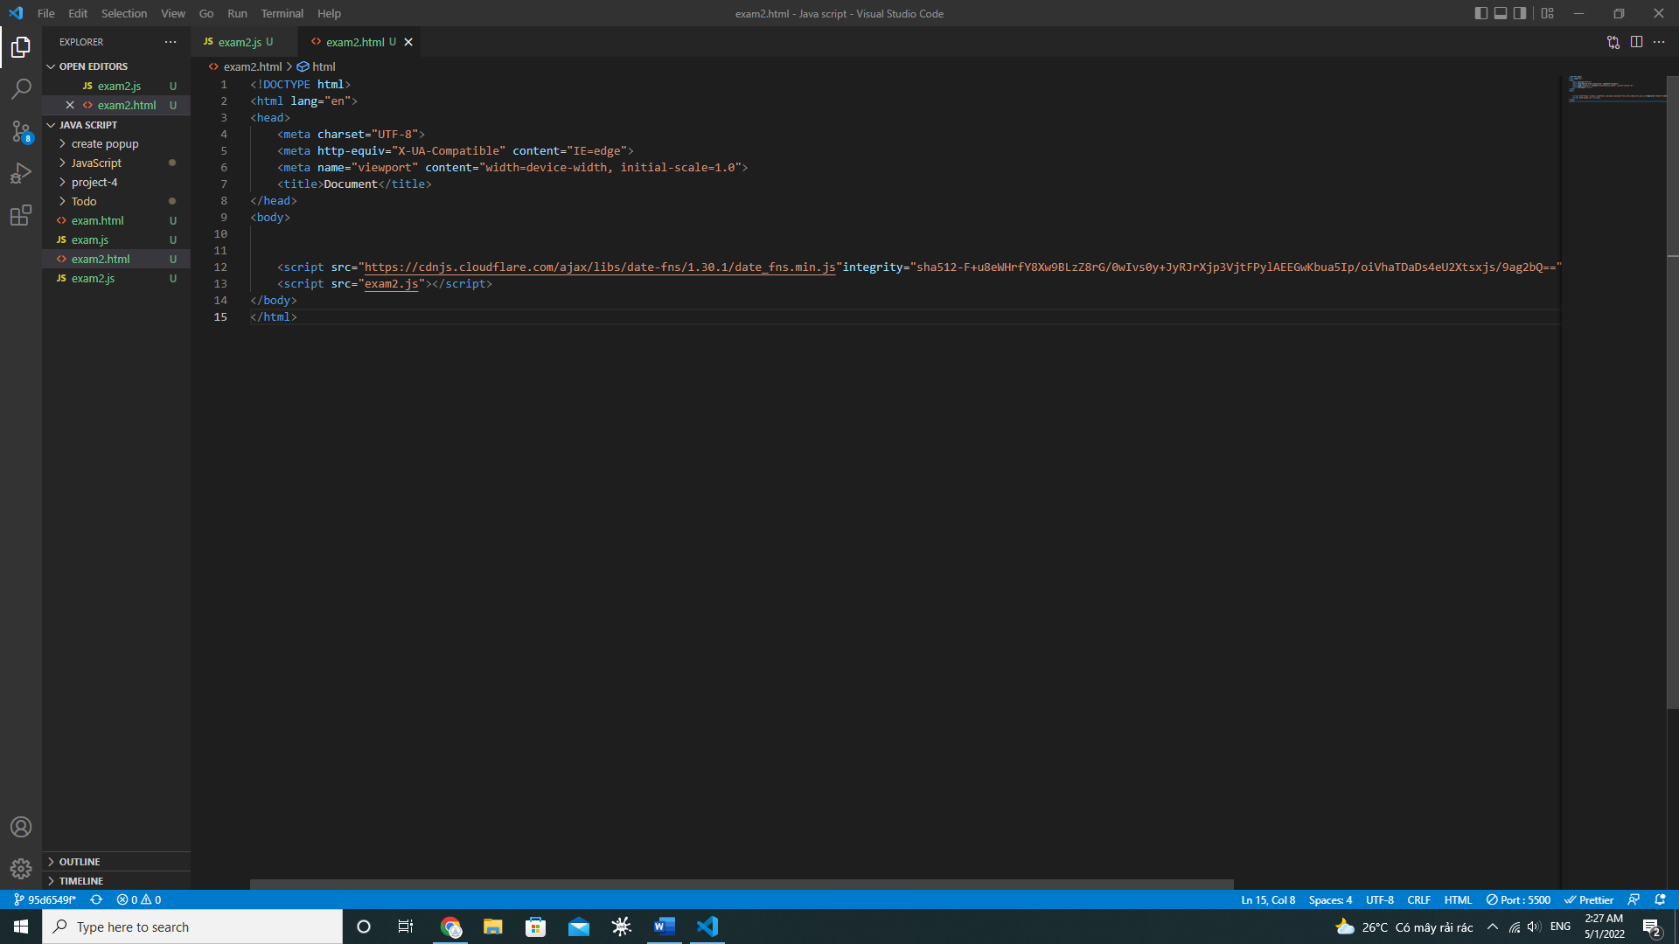
Example 1: If we want to check this day
Const now = new Date ( );
Console.log( dateFns.isToday(now) ); true
Example 2: If we check the day
Const now = new Date ( 732462363 );
Console.log( dateFns.isToday(now) ); false

//formating option
Example 3:
Console.log(dateFns.format (now, ‘YYYY’ ) );
Console.log(dateFns.format (now, ‘MMMM’ ) )
Console.log(dateFns.format (now, ‘dddd, Do, MMMM, YYYY’ ) )

Comparing dates
Example 4:
Const before = new Date ( ‘February 1 2019 12:00:00’);
Console.log(dateFns.distanceInWords(now, before ,{addSuffix: true} ) ) about ….. ago

SECTION 12: ASYNC JAVASCRIPT
I. WHAT IS ASYNCHONOROUS JAVASCRIPT
This chapter will probaly be the hardest chapter to fully understand.

